GEORGIA
PERFORMANCE STANDARDS
Macroeconomics

GEORGIA PERFORMANCE STANDARDS
INTERNATIONAL ECONOMICS

Macroeconomic Concepts

SSEMA1 The student will illustrate the means by which economic activity is measured.

a. Explain that overall levels of income, employment, and prices are determined by the spending and production decisions of households, businesses, government, and net exports.

Increased levels of spending by households, businesses, government and purchasers of exported goods and services increase aggregate demand. Overall levels of income, employment and prices are derived from the equilibrium established through the aggregate supply/aggregate demand model. Real output at a particular price level reflects the employment and real wages established in the economy as an aggregate.

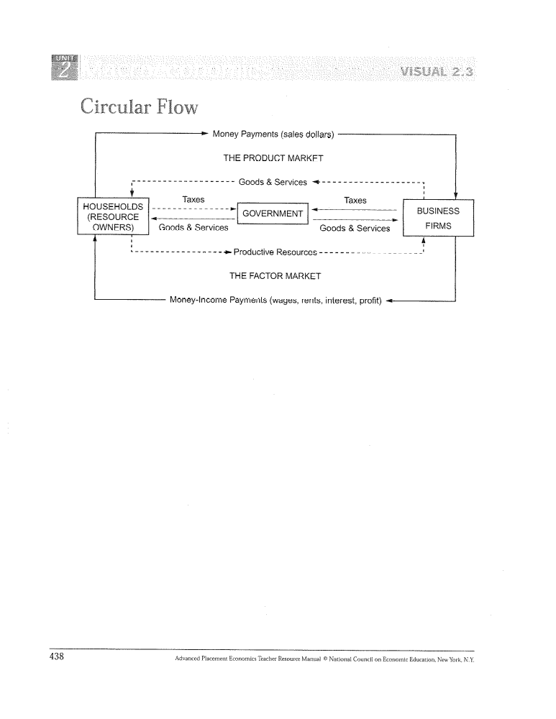

b. Define Gross Domestic Product (GDP), economic growth, unemployment, Consumer Price Index (CPI), inflation, stagflation, and aggregate supply and aggregate demand.

Gross Domestic Product (GDP)
The market value of all final goods and services produced in a country in a calendar year.
-2-
Economic Growth
An increase in real output as measured by real GDP or per capita real GDP.

Unemployment
The number of people in the civilian work force over the age of 16 without jobs who are actively seeking work.

Consumer Price Index (CPI)
A price index that measures the cost of a fixed basket of consumer goods and services and compares the cost of this basket in one time period with its cost in some base period. Changes in the CPI are used to measure inflation.

Inflation
A rise in the general or average price level of all the goods and services produced in an economy. Can be caused by pressure from the demand side of the market (demand-pull inflation) or pressure from the supply side of the market (cost-push inflation).

Stagflation
A decline in real GDP combined with a rise in the price level.

Aggregate Supply (AS)
A schedule (or graph) that shows the value of output (real GDP) that would be produced at different price levels.
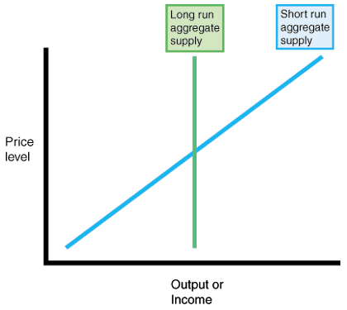

-3-
Aggregate Demand (AD)
A schedule (or graph) that shows the value of output (real GDP) that would be demanded at different price levels.

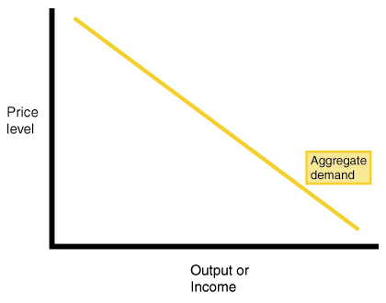

c. Explain how economic growth, inflation, and unemployment are calculated.

The government calculates economic growth by using the expenditure approach or income approach in measuring GDP. GDP is a measure of a nation’s economic output and income. It is the total market value, measured in dollars, of all goods and services produced within a country’s borders in one year.

The Consumer Price Index (CPI) is the most commonly used measure of price-level changes in the economy. It can be used to compare price levels and inflation among various years. The CPI is determined by comparing the price of a standard group of goods called a “market basket” to the price of the same group of goods in a previous month of year.

To calculate unemployment the government conducts a monthly census of about 50,000 families. These families are asked about their employment status during that month. This poll tells the government how many people are employed and how many people are unemployed. These numbers are then used to calculate the unemployment rate. To calculate the unemployment rate the government divides the number of people unemployed by the number of people in the civilian labor force and then multiplies that number by 100.

Bureau of Economic Analysis- www.bea.gov (economic growth)
Bureau of Labor Statistics- www.bls.gov (inflation, unemployment)

-4-
d. Identify structural, cyclical, and frictional unemployment.

Structural Unemployment
The type of unemployment resulting from people's present abilities, skills, training and location not matching up with available job openings that reflect the basic structure of the economy.

Cyclical Unemployment
Unemployment caused by fluctuations in the overall rate of economic activity or phase of the business cycle.

Frictional Unemployment
Unemployment that is always present in the economy, resulting from temporary transitions made by workers and employers or from workers and employers having inconsistent or incomplete information.

e. Define the stages of the business cycle, include peak, contraction, trough, recovery, expansion as well as recession and depression.

Business cycle
Fluctuations in the overall rate of national economic activity with alternating periods of expansion and contraction; these vary in duration and degrees of severity; usually measured by real gross domestic product (GDP).

Peak
The height of an economic expansion, when real GDP stops rising.
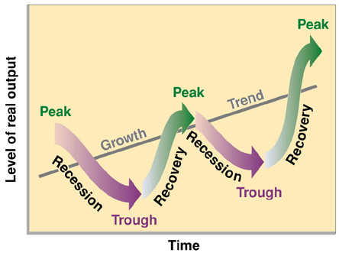
Contraction
A period of economic decline marked by
falling real GDP.

Trough
The lowest point in an economic contraction,
when real GDP stops falling.

Recovery
A period in a business cycle following a
recession, during which the real GDP rises.

Expansion
A period of economic growth as measured by a rise in real GDP.

-5-
Recession
A decline in the rate of national economic activity, usually measured by a decline in real GDP for at least two consecutive quarters (i.e., six months).

Depression
A severe, prolonged economic contraction.

f. Describe the difference between the national debt and government deficits.

National Debt
The total amount owed by the national government to those from whom it has borrowed to finance the accumulated difference between annual budget deficits and annual budget surpluses; also called public debt.

Government Deficits
A government spends more money (expenditures) in a fiscal year than it takes in (revenue) during that time.

SSEMA2 The student will explain the role and functions of the Federal Reserve System.
a. Describe the organization of the Federal Reserve System.

Its main function is controlling the money supply through monetary policy. The Federal Reserve System divides the country into 12 districts, each with its own Federal Reserve bank. Each district bank is directed by its nine-person board of directors. The Board of Governors, which is made up of seven members appointed by the President and confirmed by the Senate to 14-year terms, directs the nation's monetary policy and the overall activities of the Federal Reserve. The Chairman of this board serves a four year term (not term limited). The Federal Open Market Committee is the official policy-making body; it is made up of the members of the Board of Governors and five of the district bank presidents.

b. Define monetary policy.

Monetary Policy
Changes in the supply of money and the availability of credit initiated by a nation's central bank to promote price stability, full employment and reasonable rates of economic growth.

-6-
c. Describe how the Federal Reserve uses the tools of monetary policy to promote price stability, full employment, and economic growth.

The Fed has a number of monetary policy tools it can use to promote price stability, full employment, and economic growth (three are listed below):

Open Market Operations
The buying and selling of government bonds (securities) by the Federal Reserve to control bank reserves and the money supply. To increase the availability of money the Fed buys government bonds (securities). To tighten the availability of money the Fed sells bonds (securities).

Discount Rate
The interest rate the Federal Reserve charges commercial banks for loans. A change in the discount rate can either inhibit or encourage financial institutions’ lending and investment activities by making it more or less expensive for them to obtain funds.

Federal Funds Rate
The interest rate at which a depository institution lends immediately available funds (balances at the Federal Reserve) to another depository institution overnight.

Reserve Requirements
The fraction of banks' deposits that they are required by law to keep on hand or with the Federal Reserve. Lower reserve requirements mean banks can loan out a higher percentage of deposits, higher reserve requirements mean banks must keep a higher percentage of deposits in the vault.

SSEMA3 The student will explain how the government uses fiscal policy to promote price stability, full employment, and economic growth.
a. Define fiscal policy.

Fiscal Policy
Changes in the expenditures or tax revenues of the federal government, undertaken to promote full employment, price stability and reasonable rates of economic growth.

-7-
b. Explain the government’s taxing and spending decisions.

Government taxation
Funds raised through taxing and borrowing to pay for government expenditures. The amount of government taxation depends on a number of factors including political ideology, the state of the economy and the political climate.

Government expenditures
Goods and services provided by government and paid for by taxing and borrowing. Federal government expenditures include national defense and a system of justice. State and local government expenditures include police, roads and public education. The amount of government spending depends on a number of factors including political ideology, the state of the economy and the political climate.



